

**PROJECT TITLE**

**WORKFLOW TO CURATE AND DESSIMATE FLOODING RELATED DATA PRODUCTS AND IMPACT ASSESSMENT TO USERS USING GOOGLE EARTH ENGINE**

**(3.2 a: Technology and Standards for Geospatial Workflow)**

**Submitted to:**

Mr. Shiva Reddy

GID, IIRS

**Submitted by:**

Nalin Sharma

M. Tech (GID)

Vivek Kumar

M. Tech (GID)

Yamini Agrawal

M. Tech (PRSD)

Ashutosh Pandey

M. Tech (PRSD)

**Acknowledgment**

We are obliged to express our sincere gratitude to everyone who has encouraged us throughout the completion of the project.

Foremost, we would like to express our sincere gratitude to our module coordinator, Mr. K Shiva Reddy, Scientist / Engineer- SC, GID Department, Indian Institute of Remote Sensing (IIRS) for his governance and guidance. We are truly thankful for her support and cooperation.

We are thankful to our dedicated faculty members of the Indian Institute of Remote Sensing for clearing our unending doubts.

I would also want to express my gratitude to Dr. Sameer Saran, Scientist/Engineer-SG, Head of the GID dept., Indian Institute of remote sensing.

We are thankful to all our friends who helped us at every stage of the project work.

**TABLE OF CONTENTS**

1. INTRODUCTION 5

1.1 : Causes of Flood 5

1.2 : Impacts on daily life and on long-terms 6

1.3 Objectives: 6

2. LITERATURE REVIEW 6

3. STUDY AREA 7

4. DATASETS USED AND METHODOLOGY: 8

4.1 : Dataset Used 8

4.2 : Methodogy 8

5. RESULTS 13

6. CONCLUSION 17

7. REFERENCES 17

**LIST OF FIGURES:**

**Fig 1:** Study area of Samastipur, Bihar

**Fig 2:** Flowchart depicting the methodology and end-users

**Fig 3:** BPMN Diagram

**Fig 4:** Process Diagram for LULC

**Fig 5:** Process Diagram for quantification of affected regions

**Fig 6:** LULC map of Samastipur, Bihar using Sentinel-2 optical data

**Fig 7:** Flood inundation map in GEE using SAR COPERNICUS-1 GRD Data using HV Polarisation

**Fig 8:** Map showing flood inundated areas of Samastipur, Bihar

**Fig 9:** Map showing agricultural areas in Samastipur, Bihar before flooding

**Fig 10:** Affected agricultural areas of Samastipur, Bihar post flooding

**Fig 11:** Map showing Built-up areas in Samastipur, Bihar before flooding

**Fig 12:** Affected built up areas of Samastipur, Bihar post flooding

**List of tables:**

**Table 1:** Damage Assessment caused by flood on agriculture and built-up areas

# INTRODUCTION

Natural disasters like landslides, earthquake, cyclone, flood create miseries to mankind and in developing countries like India the results are even more severe. Various states of India every year suffer a great loss of flora and fauna due to floods. Entire villages being washed away and people stranded with nothing to live on which results in rural poverty and general backwardness of the affected area. Shortage of food and water complicates the conditions more. With the advent of technology and aid of spatial data the mapping of flood affected area has become easier.

In particular, satellite-borne Synthetic Aperture Radar (SAR) systems, because of their 24 hours and all-weather acquisition capabilities, have become the preferred tool for flood mapping from space (Dasgupta et al., 2018a; Schumann and Moller, 2015). SAR is an active system that emits microwave pulses at an oblique angle towards the target. The amount of microwave energy scattered off an object is mainly a function of its surface roughness, with shape and dielectric properties as secondary factors (Woodhouse, 2005). Rough terrestrial land surfaces reflect the energy in many directions, including back towards the sensor, and therefore appear as high backscatter zones. Conversely, open water has a relatively smooth surface which causes radar radiation to be reflected away from the sensor, resulting in low backscatter (Henderson and Lewis, 2008). This difference in backscatter response generally allows flood mapping (Ulaby et al.,1986). Nevertheless, a number of event-related and catchment-related meteorological and geometric factors can alter the backscatter char- acteristics causing errors in the detection of the flooded area. For instance, smooth surfaces such as roofs, tarmac and car parks can lead to commission errors (Giustarini et al., 2013), while roughening of the water surface due to rain and wind can lead to omission errors (Zwenzner and Voigt, 2009). Moreover, interpretation of the back-scatter response of different targets in urban and vegetated areas in the presence and/or absence of flood water represents the biggest challenge for inundation detection (Pierdicca et al., 2018; Shen et al., 2019). The detrimental impacts of floods on densely populated areas and man-made infrastructures has led to increased research efforts on flood monitoring in urbanized areas.

While optical sensors cannot detect standing water beneath vegetation, this backscatter increase enables SAR the unique opportunity to map floods in areas with protruding vegetation (Schumann and Moller, 2015).

**1.1 Causes of Flood:**

Three factors account for the frequent occurrence of flood in India. They are –

1. Bihar being in the Monsoon region
2. The existence of west plains in the north and,
3. Long stretch of mountainous region in the North and North East.

Since Bihar is located in the lower part, natural river water flows towards Bihar and all rivers join the river Ganges at different locations. During the monsoon season when there is more rain, these rivers get filled up, causing floods. The state has been facing floods ever since, but the frequency of floods has become high in recent years. There have been floods almost every year from 1979 which have caused extensive damage. Lakhs of people have lost their lives and their homes. The state has faced infrastructural losses worth crores of rupees.   
There has been increased conversion of forests to agricultural and pastural land in the middle hills of Nepal, which significantly contributes to the flood damage in India. There was an increase in the annual run off in the Sapt Kosi from the 1950s until the 1980s, but the rainfall also increased correspondingly at several stations in the basin.

## 1.2 Impacts on daily life and on long-terms:

Bihar is India's most flood-prone state, with 76% population in the North Bihar living under the recurring threat of flood devastation. Bihar makes up 16.5% of India's flood affected area and 22.1% of India's flood affected population.About 73.06% of Bihar's geographical area, i.e. 68,800 square kilometres (26,600 sq mi) out of 94,160 square kilometres (36,360 sq mi), is flood affected. On an annual basis, they destroy thousands of human lives apart from livestock and assets worth millions.In total, they have claimed 9,500 lives since the government started publishing figures in 1979.North Bihar districts are vulnerable to at least five major flood-causing rivers during monsoon – Mahananda River, Koshi River, Bagmati River, Burhi Gandak River and Gandak – which originate in Nepal. Some south Bihar districts have also become vulnerable to floods from Son, Punpun and Phalgu rivers. The 2013 flood affected over 5.9 million people in 3,768 villages in 20 districts of the state.2017 flood affected 19 districts of North Bihar killing 514 peopleand affecting 1.71 crore people (Data Source: Wikipedia)

## 1.3 Objectives:

1. Mapping of flood inundation area Using SAR.
2. Quantifying the impact of flood on agricultural and built-up areas.
   * 1. Creation of LULC map for Samastipur.
     2. Integration of LULC classes with Flood Map.

**2. LITERATURE REVIEW**

a) Yommy [et.al](http://et.al/)

The paper is about SAR image despeckling using refined lee filter. The presence of speckle noise in Synthetic Aperture Radar (SAR) images makes the interpretation of the contents difficult, thereby degrading the quality of the image. The method is based on the well-known Lee filter. In this method the K-Nearest Neighbour (KNN) algorithm is employed to adjust the number of neighbour pixels used within the sliding window. Simulation results obtained from the performance evaluation metrics used showed that the proposed method improved the performance of the original Lee filter when they were both used to despeckle standard test images contaminated with speckle noise and SAR images.

b) Tripathi [et.al](http://et.al/)

This paper talks about flood inundation mapping and impact assessment using multi temporal optical and SAR data, the study uses multitemporal Sentinel-1A (SAR) and Moderate-resolution Imaging Spectroradiometer Near Real-Time (MODIS NRT) flood data (Optical and 3-day composite) over Darbhanga district of North Bihar during August and September 2017. a binarization technique is used to extract the flood textures. wherein the threshold was applied as −22.5, −23.4, −23.8 and − 22.7 over VH polarization image. During the peak flooding, 13 % of the area were submerged. Patches can be observed in detail by LULC that agriculture patches of ~392 [sq.km](http://sq.km/) area were inundated due to flood followed by vegetation clutters (16.07 [sq.km](http://sq.km/)) and urban (8.46 [sq.km](http://sq.km/)). These results indicated the impact of floodwater on agriculture and urban patches. These findings are crucial for policymakers to assess flood impacts.

c) Duarte. Et al

This paper explores the possibilities of using QGIS cloud for hosting web maps, QGIS is a free and open-source software that allows viewing, editing, and analyzing georeferenced data. It is a Geographic Information System (GIS) software composed by tools that allow to manipulate geographic information and consequently to create maps which help to get a better understanding and organization of geospatial data. Unfortunately, maps created directly in the GIS desktop software are not automatically transferred to a website. This research aimed to compare publishing capabilities in different QGIS plugins to create Web Maps. This study analyzes four QGIS plugins (QGIS2Web, QGIS Cloud, GIS Cloud Publisher and Mappia Publisher), performing a comparison between them, considering their advantages and disadvantages, the free and subscription plans, the tools offered by each plugin and other generic aspects. The four plugins were tested in a specific case study to automatically obtain different Web Maps. This study could help users to choose the most adequate tools to publish Web Maps under QGIS.

**3. STUDY AREA:**

Samastipur([25°51′47″N ,85°46′52″E](https://geohack.toolforge.org/geohack.php?pagename=Samastipur&params=25.862931_N_85.781064_E_type:city(62935)_region:IN-BR)) is a city in [Bihar](https://en.wikipedia.org/wiki/Bihar), [India](https://en.wikipedia.org/wiki/India). and comes under [Darbhanga division](https://en.wikipedia.org/wiki/Darbhanga_division). The [Budhi Gandak](https://en.wikipedia.org/wiki/Burhi_Gandak_River) river flows through the town. Samastipur is surrounded in north by the Baghmati river which separates it from Darbhanga district, on the west by Vaishali and some part of Muzaffarpur districts, on the south by the Ganges, and on the east by Begusarai and some part of Khagaria districts. The district covers a total area of 2677.42 sq km. The climate of this district is on the whole dry, hot in summer and mild cold in winter. Agriculture is the main economic occupation of the district and about 83 per cent of the total working population depends on it. The annual rainfall varies from 1100 mm. to 1200 mm.

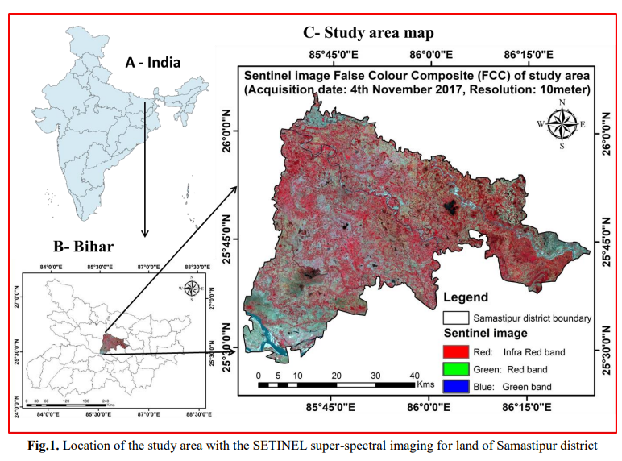

**Source:** Ahmad, Firoz & Uddin, Md Meraj & Goparaju, Laxmi. (2018). Assessment of remote sensing and GIS application in identification of land suitability for agroforestry: A case study of Samastipur, Bihar, India. Contemporary Trends in Geoscience. 7. 214-228. 10.2478/ctg-2018-0015.

**4. DATASET AND METHODOLOGY USED:**

**4.1 Dataset:**

1. COPERNICUS-1 GRD SAR dataset has been used to prepare flood inundation map as SAR dataset has the ability to penetrate through thick clouds at higher wavelength than optical data. The data has been chosen from Image Collection from the Data Catalogue of Google Earth Engine. Two dataset collections are chosen, i.e., pre-flood and post-flood. For pre-flood, dates have been chosen from 25th May,2021 to 15th June, 2021. For post flood, maximum inundation visually can be observed from 20th July, 2021 to 31st July, 2021.
2. For preparation of LULC Map, Sentinel-2 Optical data has been downloaded from USGS Earth Explorer which is freely available at 10m resolution for entire globe.

**4.2 Methodology:**

The mapping of flood inundation areas has been done using COPERNICUS-1 GRD SAR dataset since it provides cloud penetration at higher wavelength than optical data. The process has been carried out on Google Earth Engine platform. Firstly, the shapefile of Samastipur, Bihar has been uploaded and called as an object. A feature collection containing the COPERNICUS-1 GRD SAR has been selected. For flood mapping, two datasets are required, i.e., pre-flood and post-flood. For pre-flood, dates have been chosen from 25th May,2021 to 15th June, 2021. For post flood, maximum inundation visually can be observed from 20th July, 2021 to 31st July, 2021. The scenes from the two datasets had been mosaiced to create a single scene for each of the datasets. Then the two scenes were filtered using RefinedLee to remove any speckle noise. The SAR image represents the scattering values in terms of dbs.

Thresholding method has been used for mapping flood using SAR imagery as the backscattering value of water bodies, due to their smooth surface is very low and hence they appear dark in SAR imagery. For flood mapping, if the pre-flood image has pixel value less than -20db, it has been characterised as a water body. If not, it is characterised as a non-water body. After that, in the after image, if the pixel value for a non-water body class in the pre-flood scene is now less than -20db, it has been characterised as flood region. If it is not less than -20db, then that region has not been affected by flood. A flood inundation map has been generated in GEE using above methodology (fig ).

To map how much the flood has affected the livelihood of people, a LULC (Land Use Land Cover Map) has been prepared using Sentinel-2 Optical data for Samastipur, Bihar in ArcMap. For LULC Preparation, two scenes of same date have been used. A composite band having bands Blue, Green, Red, NIR, SWIR1, SWIR2 have been created. The two scenes are then mosaiced and clip to shape using the Samastipur shapefile. Training samples for classes Agriculture, Built-up, water, Trees Cover and Fallow/Barren Land are then collected to be used for supervised classification. Using supervised classification, LULC map has been prepared.

Since Built-up and Agricultural classes are the most affected areas by flood and cause maximum damage to people’s livelihood, damage assessment for these two classes has been carried out. To quantify the change the flood has caused to these classes, first, these classes have been extracted individually from the LULC by using CON operator in ArcMap. Then pixel-wise multiplication has been carried out by multiplying each class to the flood map generated before so that the regions affected by flood are highlighted. These raster layers have then been converted into polygon shapefiles to calculate the area which has been affected by flood. Percentage change has been calculated and damage assessment has been done by calculating areas for pre-flood and post-flood agriculture and built up classes by using the formula:

**Flowchart:**

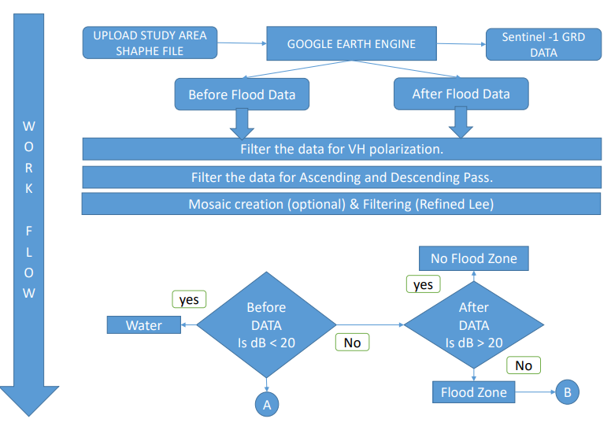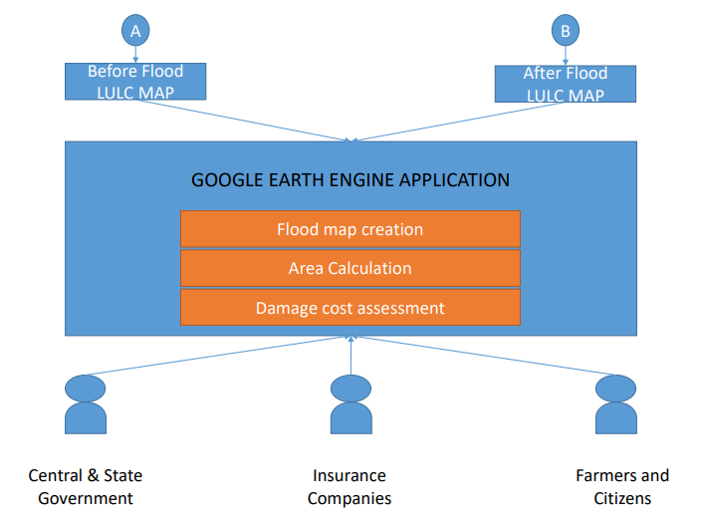

**Fig 2:** Flowchart depicting the methodology and end-users

**BPMN DIAGRAM:**

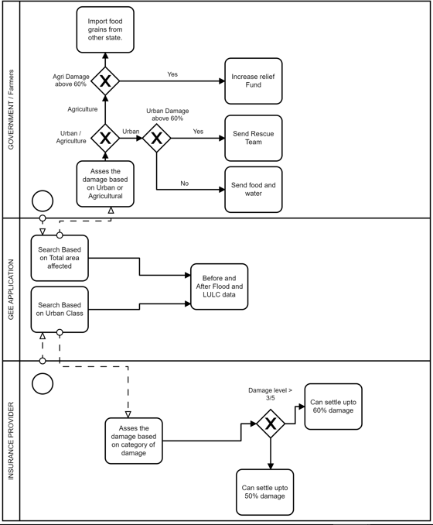

**Fig 3:** BPMN Diagram

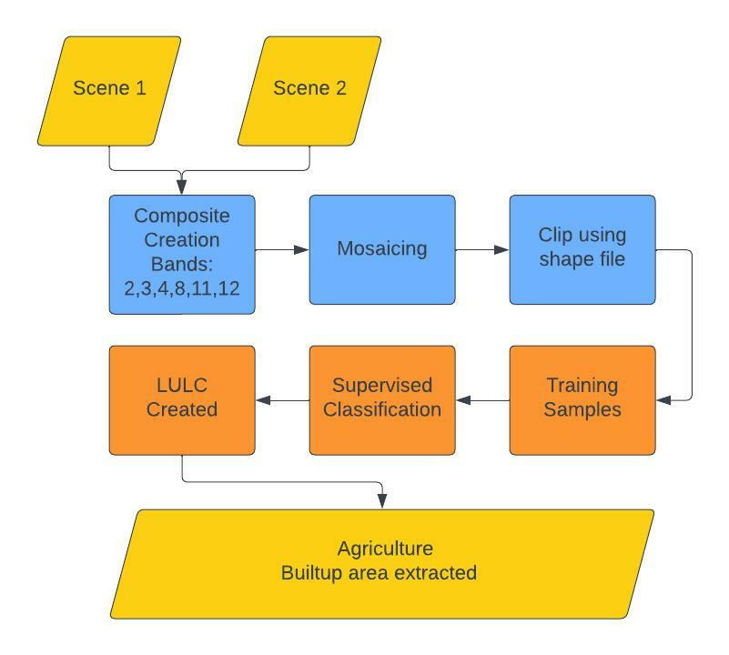

**Fig 4:** Process Diagram for LULC

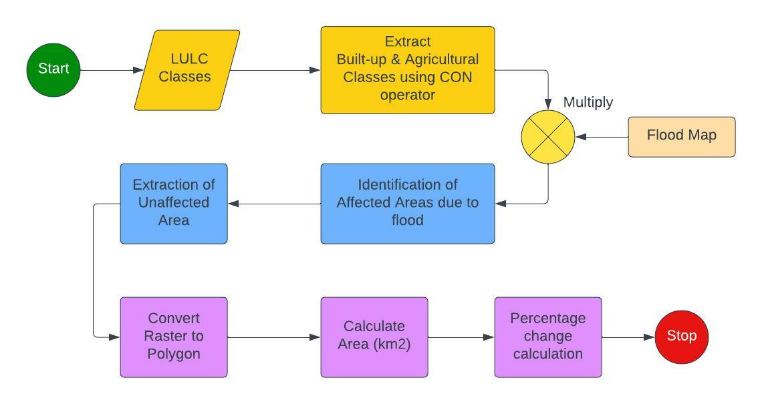

**Fig 5:** Process Diagram for quantification of affected regions

**RESULTS:**

Using Sentinel-2 optical data, LULC Map of Samastipur Bihar has been prepared (fig ).

Using Google earth Engine, flood mapping has been done for Samastipur using Sentinel-1 SAR data using thresholding method.

Damage assessment has been carried out for Agricultural and built-up classes by calculating the percentage change observed in the pre-flood and post-flood areas which can be used by government stakeholders and insurance companies to assess the damage in a better way and arrange for resources in a timely manner. Remote Sensing helps the policy makers for timely and accurate assessment of disasters where in-situ assessment is difficult and resources have to be distributed in a timely manner.

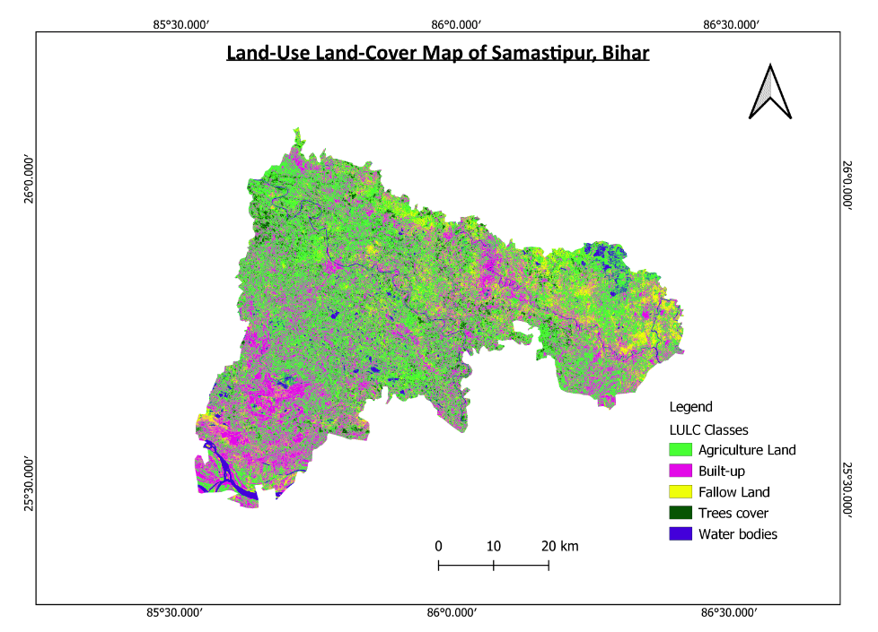

**Fig 6:** LULC map of Samastipur, Bihar using Sentinel-2 optical data

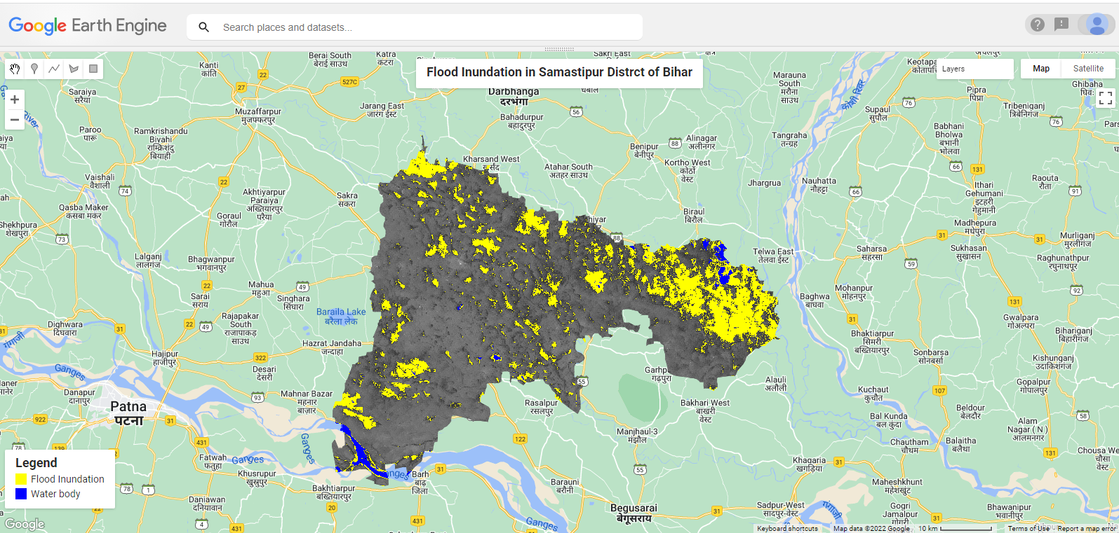

**Fig 7:** Flood inundation map in GEE using SAR COPERNICUS-1 GRD Data using HV Polarisation

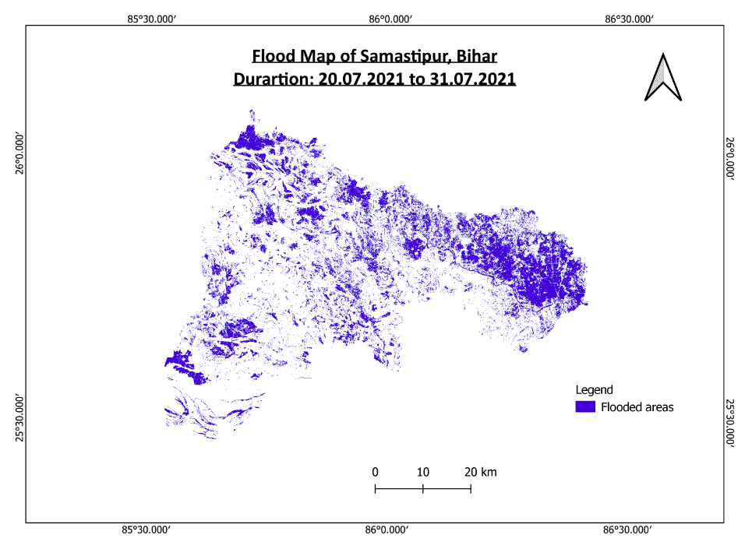

**Fig 8:** Map showing flood inundated areas of Samastipur, Bihar

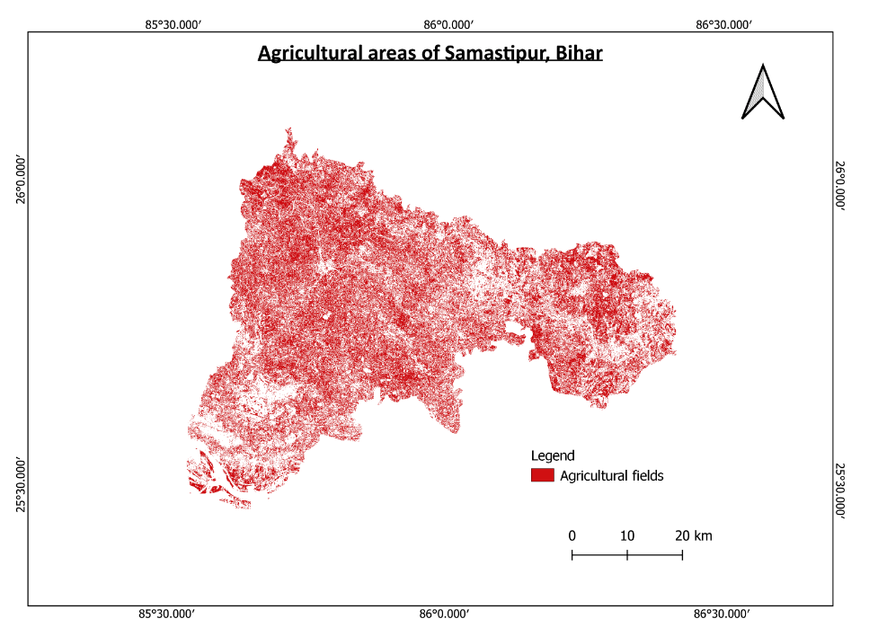

**Fig 9:** Map showing agricultural areas in Samastipur, Bihar before flooding

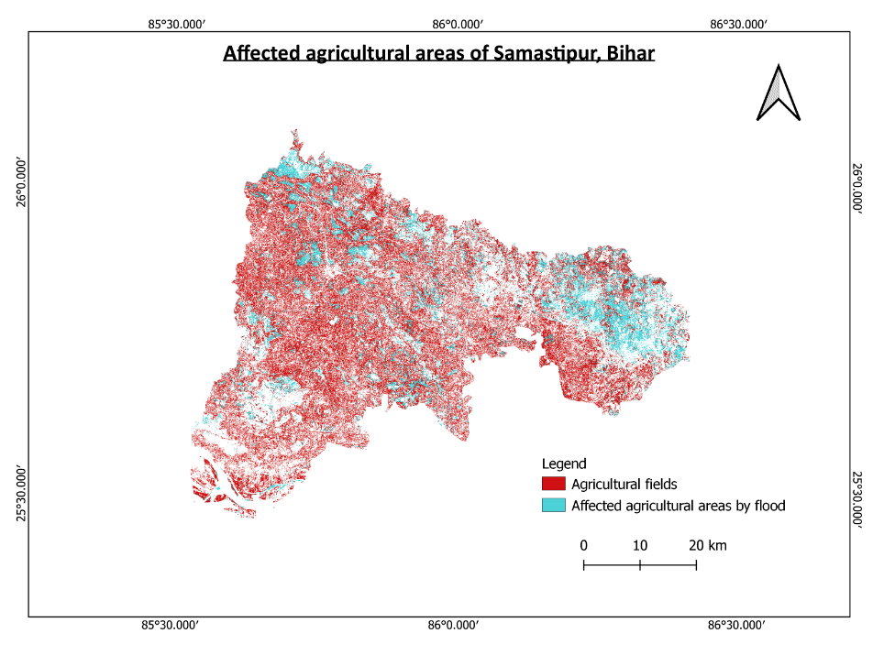

**Fig 10:** Affected agricultural areas of Samastipur, Bihar post flooding

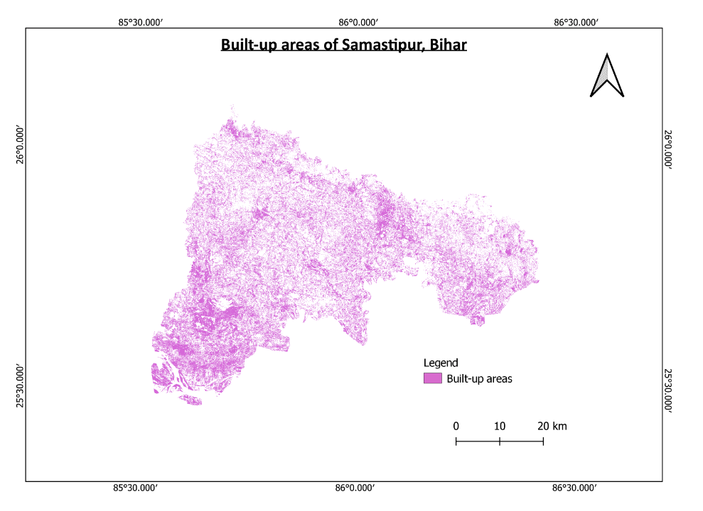

**Fig 11:** Map showing Built-up areas in Samastipur, Bihar before flooding

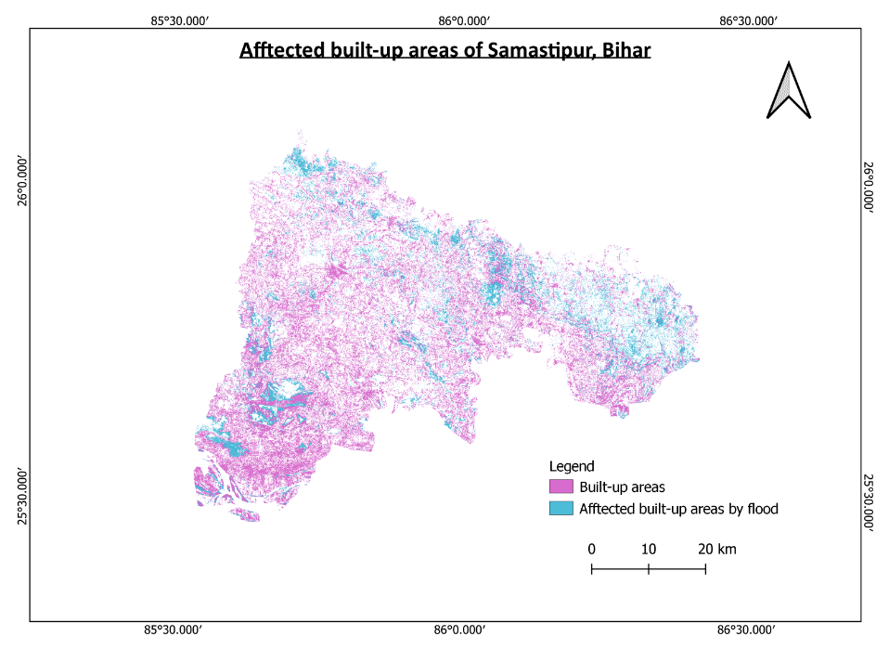

**Fig 12:** Affected built up areas of Samastipur, Bihar post flooding

**Total area of Samastipur District, Bihar: 2907.17 km2**

**Total flood area: 717 km2**

**Table 1: Damage Assessment caused by flood on agriculture and built-up areas**

|  |  |  |  |
| --- | --- | --- | --- |
| **Class** | **Pre-flood area (in km2)** | **Post-flood area (in km2)** | **Percentage Change (%)** |
| Agricultural fields | 1357.68 | 1045.164 | 23.0183 |
| Built-up areas | 988.399 | 758.422 | 23.267 |

**CONCLUSION:**

Damage assessment has been carried out for Agricultural and built-up classes by calculating the percentage change observed in the pre-flood and post-flood areas which can be used by government stakeholders and insurance companies to assess the damage in a better way and arrange for resources in a timely manner. Remote Sensing helps the policy makers for timely and accurate assessment of disasters where in-situ assessment is difficult and resources have to be distributed in a timely manner.

**REFRENCES:**

1. Ahmad, Firoz & Uddin, Md Meraj & Goparaju, Laxmi. (2018). Assessment of remote sensing and GIS application in identification of land suitability for agroforestry: A case study of Samastipur, Bihar, India. Contemporary Trends in Geoscience. 7. 214-228. 10.2478/ctg-2018-0015.